Jalu Chaudhary

Class IT-314-DL2

Hand on assignment 5

1. Determine how many books are in the cooking category.

2. Display the number of books with a retail price of more than $30.00.

3. Display the most recent publication date of all books sold by JustLee Books.

4. Determine the total profit generated by sales to customer 1017. Note: Quantity should be

reflected in the total profit calculation.

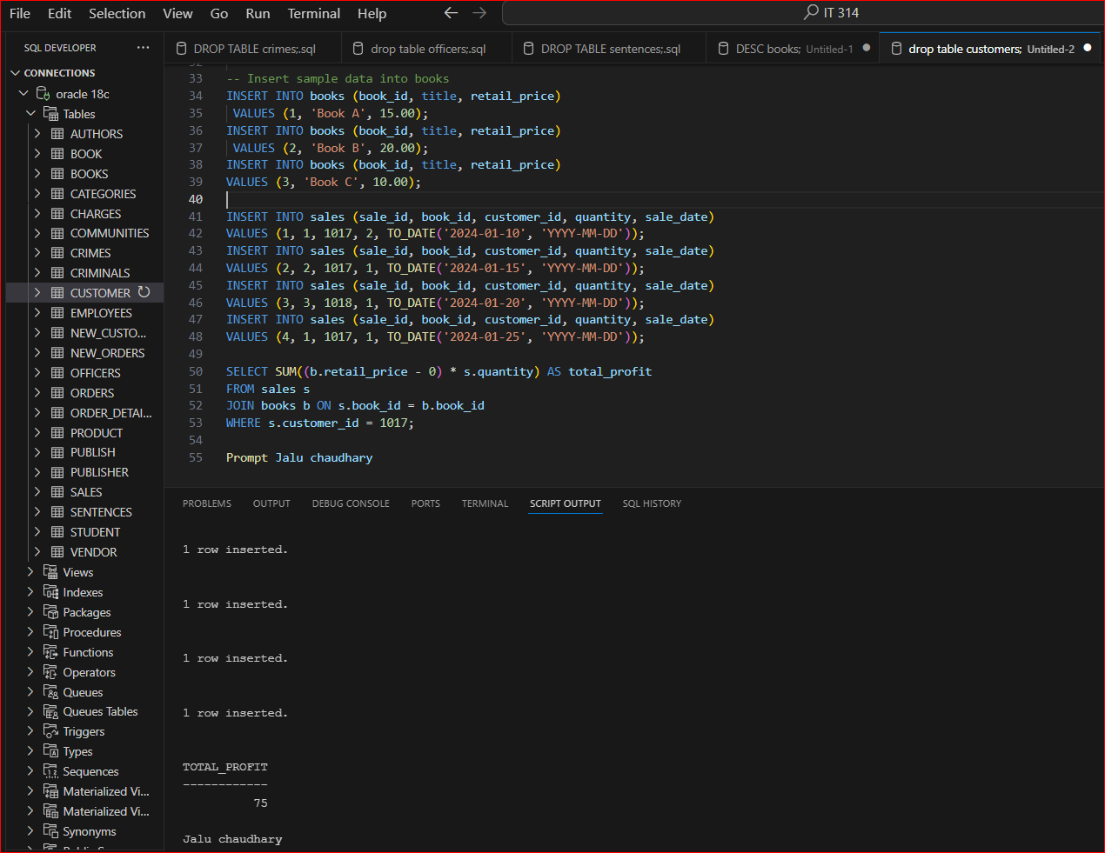

5. List the retail price of the least expensive book in the computer category.

6. Determine the average profit generated by orders in the ORDERS table. Note: The total

profit by order must be calculated before finding the average profit.

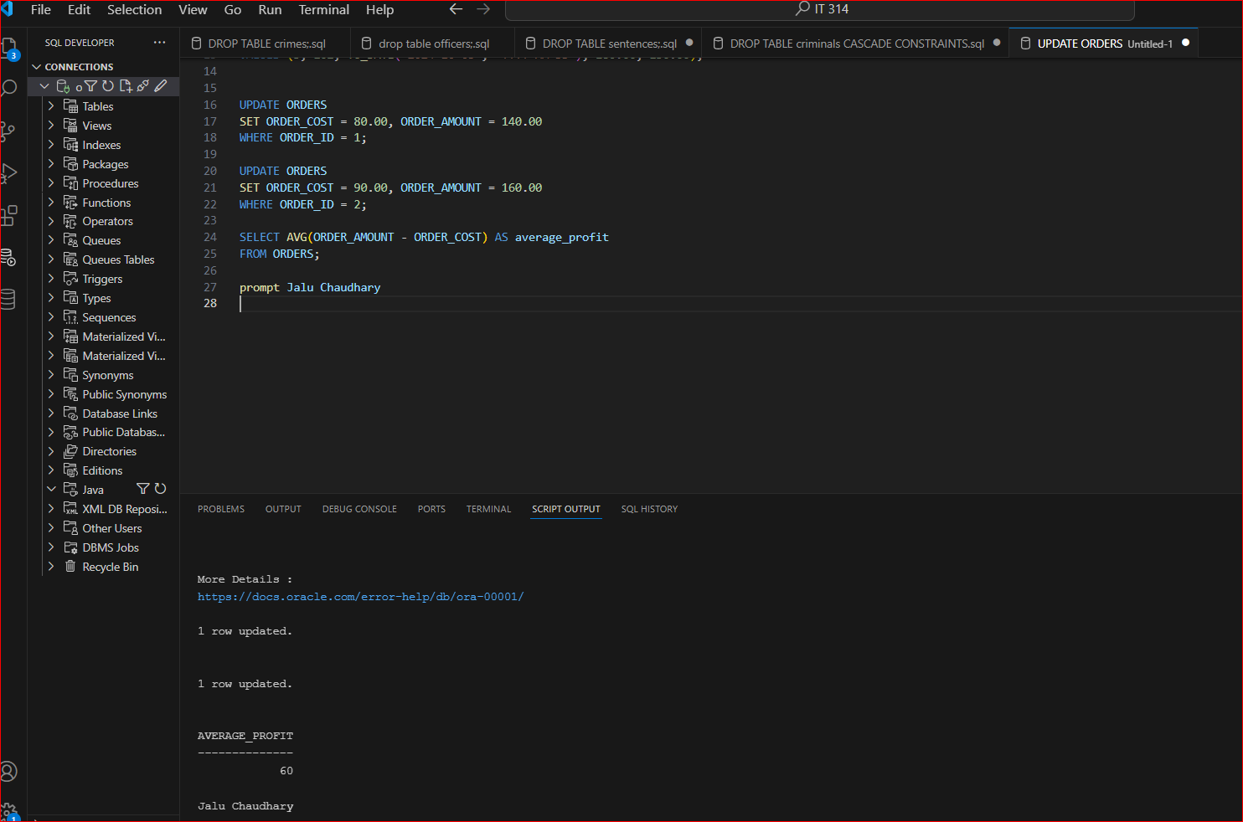

7. Determine how many orders have been placed by each customer. Do not include in the

results any customer who hasn’t recently placed an order with JustLee Books.

8. Determine the average retail price of books by publisher name and category. Include only

the categories Children and Computer and the groups with an average retail price greater

than $50.

9. List the customers living in Georgia or Florida who have recently placed an order totaling

more than $80.

10. What’s the retail price of the most expensive book written by Lisa White?

